PRESS RELEASE
For Immediate Release

NEON GALLERY x ZONA MACO
Myths in a Post-Digital Era
Booth EJ14

Presenting works by Piers Alsop (b. 1984, London) and Hugo Lami (b. 1994, Portugal)

(8 February, Mexico City) – Neon Gallery is honoured to be participating within the Ejes section of the prestigious Zona Maco Art Fair, which takes place in Mexico City between the 9th and 13th February 2022. The gallery can be found at booth number EJ14.

Under the theme of ‘Myths in a Post-Digital Era,’ Neon Gallery is proud to present a variety of works by two exceptional and acclaimed artists: Piers Alsop and Hugo Lami.

Piers Alsop’s (b. 1984, London) unique approach to painting often exhibits the co-existence of different styles and techniques on the same canvas. He enjoys the spectrum of realism pervading through to the abstract, producing a montage aesthetic that does away with traditional perspective. At times it calls to mind prop facades from a stage production. He regularly takes compositional elements from Byzantine or Renaissance religious paintings and pares them down to their most basic shapes before applying vivid colour. The more representational components appear as though they are invading these colour vacuums, contaminating them with narrative. He says, “I’d like my paintings to read a bit like medieval illustrations for parishioners attending their local gallery on a Sunday.”

Piers studied Fine Art at UAL: Camberwell College of Arts, graduating in 2007. He exhibited around the UK before pursuing a career in film, and in 2018 he was selected by the Royal Academy to exhibit in their 250th anniversary Summer Exhibition.
Complementing and building upon the narrative, the works of Hugo Lami (b. 1994, Portugal) invite the fair’s visitors to envision the digital and virtual absurdity of contemporary culture, evoking our social dependency on technological devices and social media. The body of works we’re presenting at the fair investigate the hardware of our technological evolution by fusing concepts and objects, while displacing them in time. In this way, the works create innovative narratives of possible Utopian and Dystopian futures that could quite easily become reality. Hugo's work unfolds across painting, sculpture, multimedia installation, performance, and most recently digital art, via an augmented reality app that expands his physical paintings into virtual sculpture.
Hugo holds a Masters in Sculpture from the Royal College of Art and a Degree in Painting from the Lisbon Fine Arts Academy. Hugo has been exhibiting in galleries and institutional spaces across Europe since 2014. He made his first public sculpture in 2018, and in 2019 he was awarded the Public’s Choice Award at VIA Arts Prize, London.
Neon Gallery is confident that both Piers Alsop and Hugo Lami will not only add to the creative narrative of Zona Maco’s artistic programme but will also serve as an excellent introduction to two outstanding emerging young artists who are enjoying flourishing careers in the UK and Europe. We very much look forward to welcoming you to our booth.

EXHIBTION DETAILS:
Title: NEON GALLERY x ZONA MACO
Booth: EJ14
Artists: Piers Alsop & Hugo Lami
Gallery: Neon Gallery
Exhibition Address: CENTRO CITIBANAMEX
Exhibition Dates: 9th till 13th February 2022

NOTES TO EDITORS:

Neon Gallery is a modern and contemporary art gallery with offices in New York and London. It was established in early 2020 with a mission to create transparent, egalitarian, and engaging art experiences. It is led by Christopher Shake and Dr Dimitrios Tsivrikos, two accomplished art advisors who combine their experience from the worlds of Wall Street investment banking and record sales at art auctions to create a gallery that is innovating outdated art-world models to leverage the global art market and support artists, collectors and art world leaders. Neon Gallery understands and fully supports the personal journey of education, inspiration, and discovery that is part of art appreciation and is strongly committed to equality and diversity in the art world.

CONTACT:
Dr Dimitrios Tsivrikos
dimitrios@neonartgallery.com
+44 7870 163043

IMAGE 1:
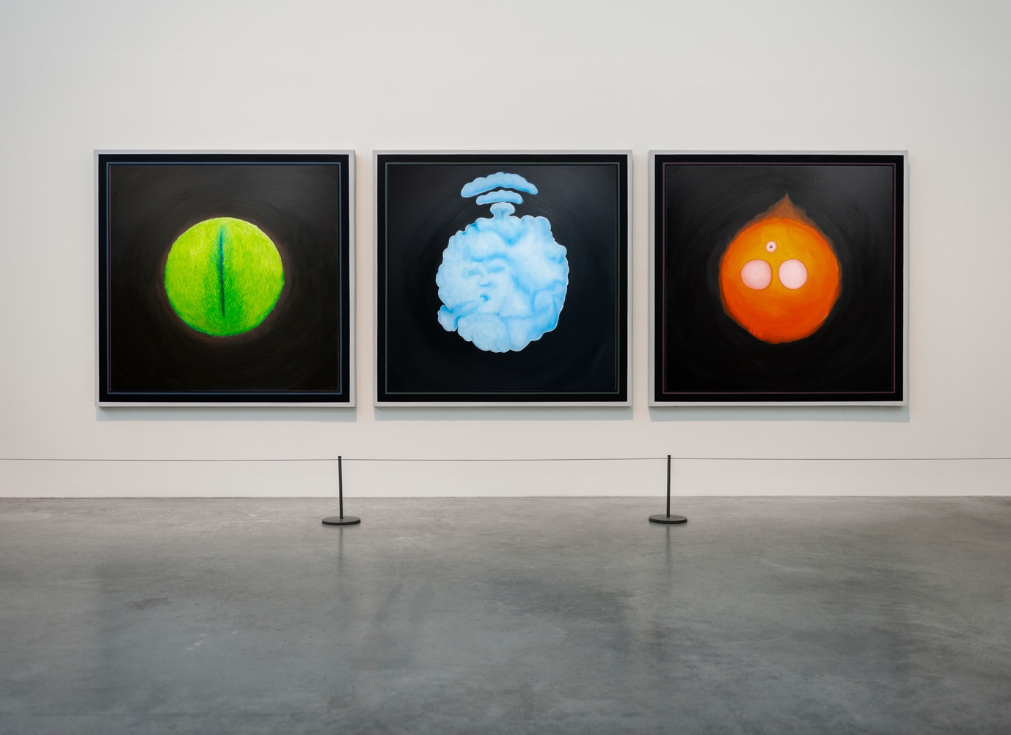

Works of Hugo Lami. Untitled Planets 1, 2 and 3, 2022. 100 x 100 cm each. Oil on linen.

IMAGE 2:

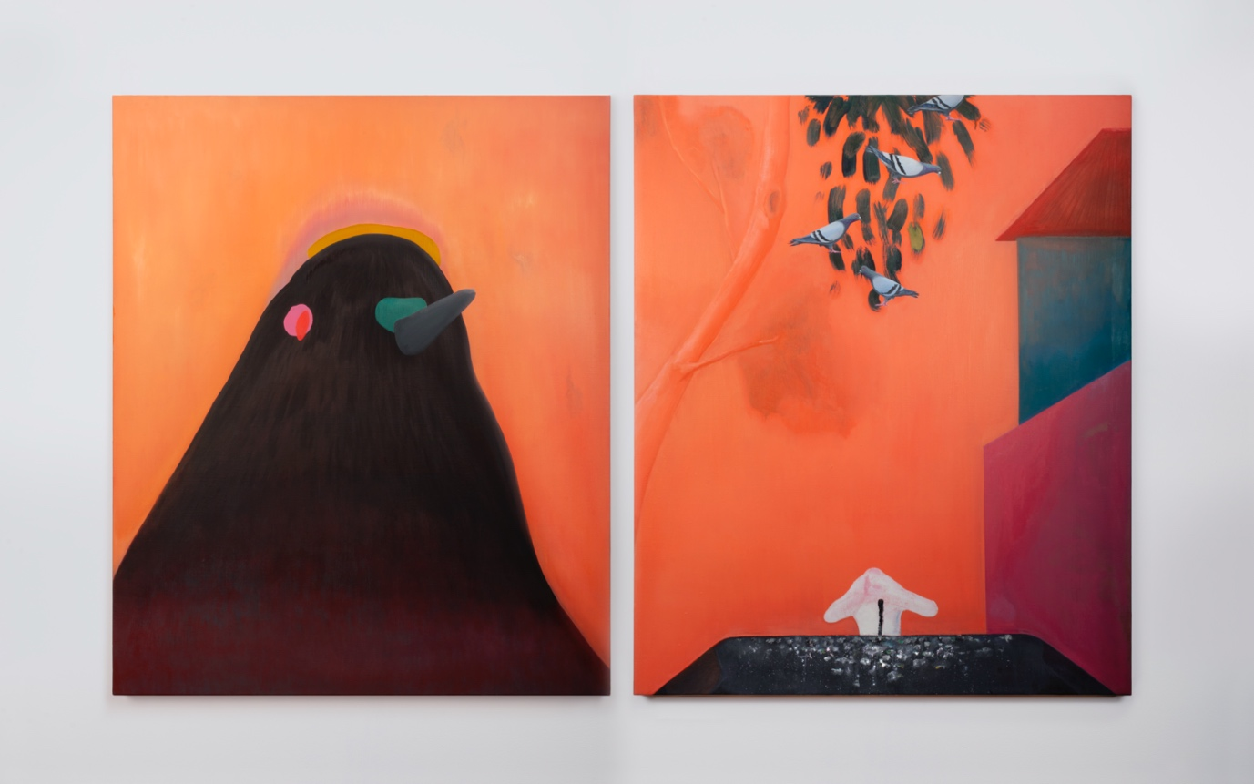

Works by Piers Alsop. Peggy & Autumn, 2020-2021. 135 x 110 cm. Oil on linen.

